15A03 Espacios vector, dependencia lineal

Explicación general
Consúltese http://mathworld.wolfram.com/Vector.html

Suma y resta
(http://en.wikibooks.org/wiki/Calculus/Vectors)
Graphically, adding two vectors together places one vector at the end of the other. This is called tip-to-tail addition: The resultant vector, or solution, is the vector drawn from the initial point of the first vector to the terminal point of the second vector when they are drawn tip-to-tail:
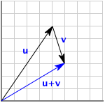
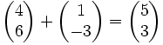
Numerically:
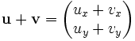
(De Cain y Herod: Multivariable Calculus, Ch. 2).
Look at the picture and convince yourself that the it does not matter which u spear or v spear you choose, and that u v v u + = + :
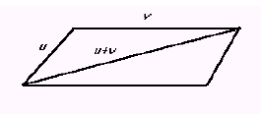

Convince yourself also that addition is associative: u + (v + w) = (u + v) + w. Since it does not matter where the parentheses occur, it is traditional to omit them and write simply u + v + w.
Subtraction is defined as the inverse operation of addition. Thus the difference u-v of two vectors is defined to be the vector you add to v to get u. In pictures, if u is a representative of u and v is a representative of v, and we put the tails of u and v together, the directed segment from the nose of v to the nose of u is a representative of u - v:
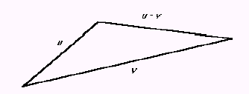

Vectores, expresados en coordenadas
(De Cain y Herod: Multivariable Calculus, Ch. 2).
The correspondence is quite easy; simply take a representative of the vector u and place its tail at the origin. The point at which is found the nose of this representative is the point associated with u. We handle the vector with no representatives by associating the origin with the zero vector. The fact that the point with coordinates (a, b, c) is associated with the vector u in this manner is shorthandedly indicated by writing u = (a, b, c). Strictly speaking this equation makes no sense; an equivalence class of directed line segments cannot possible be the same as a triple of real numbers, but this shorthand is usually clear and saves a lot of verbiage (The numbers a, b, and c are called the coordinates, or components, of u.).

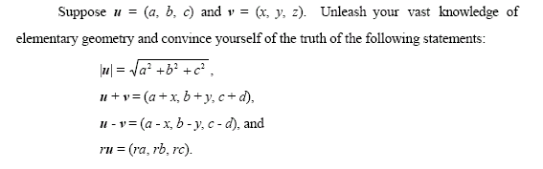

Vectores estándar
(De Cain y Herod: Multivariable Calculus, Ch. 2).
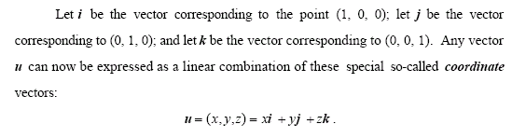

Multiplicación por un escalar
(http://en.wikibooks.org/wiki/Calculus/Vectors)
Graphically, multiplying a vector by a scalar changes only the magnitude of the vector by that same scalar. That is, multiplying a vector by 2 will "stretch" the vector to twice its original magnitude, keeping the direction the same.
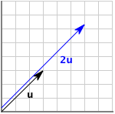Fig: 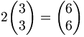
Numerically, you calculate the resultant vector with this formula:
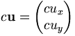, where c is a constant scalar.
As previously stated, the magnitude is changed by the same constant:
Since multiplying a vector by a constant results in a vector in the same direction, we can reason that two vectors are parallel if one is a constant multiple of the other -- that is, that if for some constant c.
We can also divide by a non-zero scalar by instead multiplying by the reciprocal, as with dividing regular numbers:
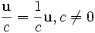

(De Cain y Herod: Multivariable Calculus, Ch. 2):
Next we define the product of a scalar r (i.e., real number) with a vector u. The
product ru is defined to be the vector with length |r||u| and direction the same as the
direction of u if r > 0, and direction opposite the direction of u if r < 0. Convince
yourself that all the following nice properties of this multiplication hold:
(r + s)u = ru + su ,
r ( u + v ) = ru + rv.
0u = 0, and
u + (-1)v = u - v.
It is then perfectly safe to write - u to stand for (-1)u.

Producto escalar (o producto punto)
(De Cain y Herod: Multivariable Calculus, Ch. 2).
It is a scalar and hence is called the scalar product. This scalar product u v ⋅ is defined by
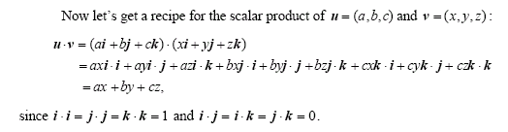

De Crenshaw: "Motivationally Speaking" (embeded.com, 26 Oct 2006, http://www.embedded.com/columns/pt/showArticle.jhtml?articleID=193402564 )
Figure 1 shows the motivation for the dot product. In physics, when you exert force on an object, and it moves some distance, you are doing work, in the rigorous physics use of the term. If you're pushing on a brick wall, it may feel like you're doing work; you may get hot and sweaty and tired, but you haven't done work in the rigorous sense. No motion, no work.
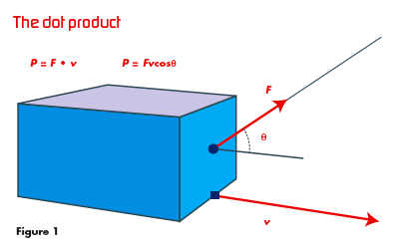
What's more, you only get credit for the motion that goes in the direction you're pushing. It's only the component of motion parallel to the force, that counts. From geometric considerations, it's easy to show that the work is:
(1)
where θ is the angle between the two vectors. If we define the dot product to be:
(2)
Then we can write the vector equation:
(3)
In physics, all operations in which the product of two vectors gives a scalar result, are dot products. In general, we'd rather not have to find the angle between vectors to get the answer. Fortunately for us, and even more fortunately for computer implementations, we don't have to. Suppose we define two vectors as Cartesian vectors, meaning three components along coordinate axes that are mutually perpendicular. Let:
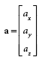
(4)
And similarly for b. In that case, the dot product is simply:
(5)
Easy, huh? The computer implementation is almost a one-liner. See Listing 2.
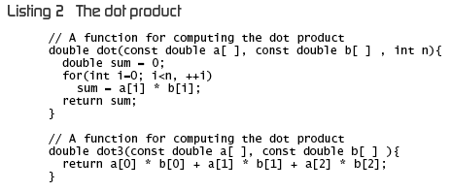
You will note that there is absolutely no error checking in this code. We must assume that the programmer knows what he's doing and won't use the library improperly. I realize that this is not a very robust approach. But it's certainly efficient, and it's very much in the good old Fortran tradition.

Vectores unitarios
(http://en.wikibooks.org/wiki/Calculus/Vectors)
A unit vector is a vector with a magnitude of 1. The unit vector of u is a vector in the same direction as , but with a magnitude of 1:
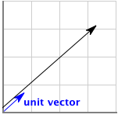
The process of finding the unit vector of u is called normalization. As mentioned in scalar multiplication, multiplying a vector by constant C will result in the magnitude being multiplied by C. We know how to calculate the magnitude of . We know that dividing a vector by a constant will divide the magnitude by that constant. Therefore, if that constant is the magnitude, dividing the vector by the magnitude will result in a unit vector in the same direction as :
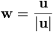, where is the unit vector of

Vectores estándar
(http://en.wikibooks.org/wiki/Calculus/Vectors)
There are two special unit vectors. i points one unit directly right in the x direction, and j points one unit directly up in the y direction:
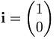
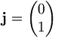
Using the scalar multiplication and vector addition rules, we can then express vectors in a different way:
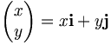
If we work that equation out, it makes sense. Multiplying x by i will result in the vector 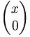. Multiplying y by j will result in the vector 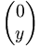. Adding these two together will give us our original vector, 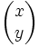. Expressing vectors using i and j is called standard form.

Producto vectorial (cross product)
Véase Feyman et al.: Física, Capítulo 20, Rotación en el espacio.
20-1 Torques en tres dimensiones, p. 20-5.
... si fuéramos a calcular a_{x}b_{y}-a_{y}b_{x} donde a y b son vectores y llamáramos componente z de una nueva cantidad c, entonces estas nuevas cantidades forman un vector c. Necesitamos una notación matemática para la relación entre el nuevo vector, con sus tres componentes, y los vectores a y b. La notación que ha sido diseñada para esto es c = a x b, esto es lo mismo que escribir
c_{x =} a_{y}b_{z} - a_{z}b_{y}
c_{y =} a_{z}b_{x} – a_{x}b_{z}
c_{z =} a_{x}b_{y} - a_{y}b_{x}

De http://en.wikibooks.org/wiki/Calculus/Vectors:
The cross product of two vectors is a determinant:
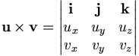
and is also a pseudovector.
The cross product of two vectors is orthogonal to both vectors. The magnitude of the cross product is the product of the magnitude of the vectors and the sin of the angle between them.
This magnitude is the area of the parallelogram defined by the two vectors.
The cross product is linear and anticommutative. For any numbers a and b,
If both vectors point in the same direction, their cross product is zero.

De Crenshaw: "Motivationally Speaking" (embeded.com, 26 Oct 2006, http://www.embedded.com/columns/pt/showArticle.jhtml?articleID=193402564 )
The other product shown in Figure 2 is the cross product.
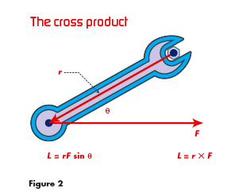
As I mentioned, it might seem bizarre and arbitrary, but it's based on physical laws that really define the operation. Imagine that you're loosening a bolt using a wrench. When you pull on the wrench, you exert a force, and the force acting over the lever arm of the wrench produces a torque. But, similarly to the dot product, the only component of the force that matters is the one perpendicular to the wrench handle. You can pull in other directions all you like, but it won't contribute to the torque. If you were using a torque wrench, the readout would only read the value associated with that perpendicular component. It's relationships like this that define the way a cross product works. Notationally, we write:
(6)
where L is the torque. Its magnitude is given by the definition:
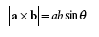(7)
Its direction is something very weird and wonderful. The vector of the cross product is perpendicular to both input vectors. Now, there are two possible directions that fit this rule. The right one is . . . um . . . the right one. That is, it's the one defined by the right-hand rule. Here's how it works. Imagine that you're rotating vector r into vector F. That is, place your right hand in such a way that, if you rotated r in the direction your fingers point, it would be parallel to F. Now stick out your thumb. It points in the direction of r × F.
Is that weird, or what? Yet the rule fits what happens in the real world. In the case of the wrench, the torque vector points along the direction the bolt will loosen.
Torque, angular momentum, and many other physical parameters are cross products. The use of cross products got a whole lot more interesting when we discovered that magnetic and electrical forces obey cross-product rules. When an electron moves through a magnetic field, the force exerted is given by:
(8)
Where q is the electric charge, v the velocity, and B the magnetic field strength. So, you see, we didn't just make up the rules about cross products to make life harder for you. The universe really, truly works this way.
Is there a method for computing the cross product, that doesn't involve q? Yes, in fact there is. I won't go into the derivation, because it involves a determinant. But the algorithm for c = a × b is:
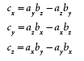
(9)
The code follows directly from this. It's shown in Listing 3. Remember, this definition only works for 3-vectors. For convenience, you can implement a version for n-vectors where n = 3. Use an assertion to make sure that the function is never called otherwise. My advice, however, is to only implement the 3-vector function, and that's what I've done.
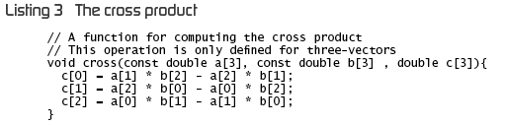
With vector add, subtract, and dot and cross product, we've pretty much exhausted the operation one can do.
(De Cain y Herod: Multivariable Calculus, Ch. 2).
The vector product of vectors u and v is defined by

where θ is the angle between u and v and n is a vector of length 1 (such vectors are called unit vectors) which is orthogonal to both u and v and which points in the direction a righthand threaded bolt would advance if u were rotated into the direction of v.
[...]
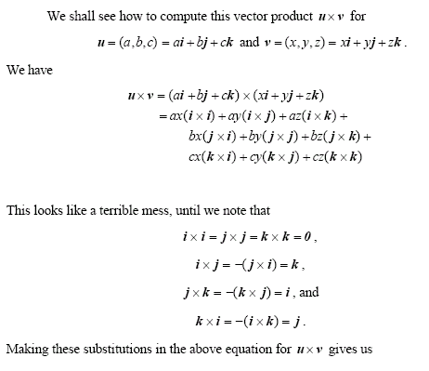
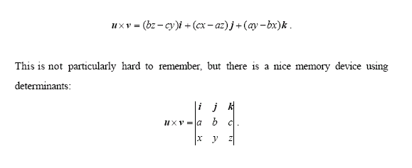

Componentes paralelos y perpendiculares
(http://en.wikibooks.org/wiki/Calculus/Partial_differential_equations)
any vector r can be split up into components parallel and perpendicular to a,
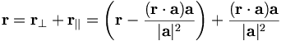

Acordeón de operaciones básicas de vectores con Maxima
/* Definición de vectores como matrices */
vecU:matrix[4,6,5,0];
vecV:matrix[1,-3,2,0];

/* Suma y resta de vectores */
vecU+vecV;
vecU-vecV;

/* Dibujo en R² de la suma de vectores */
linU:[ [0,0] , [ vecU[1],vecU[2] ] ];
linV:[ [0,0] , [ vecV[1],vecV[2] ] ];
ptsOri: [ [0,0] ] ;
linUmasV:[ [0,0] , [ vecU[1]+vecV[1],vecU[2]+vecV[2] ] ];
plot2d( [ [discrete,linU] , [discrete,linV] , [discrete,linUmasV] , [discrete,ptsOri] ] ,
[x,min(vecU[1],vecV[1])-3,max(vecU[1],vecV[1])+3] , [y,min(vecU[2],vecV[2])-3,max(vecU[2],vecV[2])+3], [ style,[lines,2,1],[lines,2,4],[lines,2,2],[points,5,0,3] ] , [legend,"U","V","U+V","Orig"] , [xlabel,"x"] , [ylabel,"y"] , [plot_format,gnuplot] );

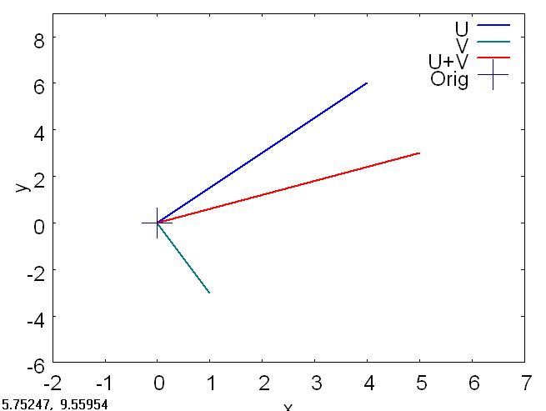

/* Producto del vector por un escalar */
esc1 : 5;
vecU . esc1;

/* Resultado: */
/* [20, 30, 25, 0] */

vecW:copymatrix(vecU);
vecW : vecU * esc1;
/* Resultado: */
/* [20, 30, 25, 0] */

xy:[ [0,0] , [ vecW[1],vecW[2] ] ];
/* Resultado: */
/* [[0, 0], [20, 30]] */

/* Módulo del vector */
Mod_xy_VecU : sqrt( (vecU[1]^2) + (vecU[2]^2) );
/* Resultado: */
/* 2 sqrt(13) */
ev(%,numer);
/* Resultado: */
/* 7.211102550927978 */

(%i104) Mod_xy_VecV : sqrt( (vecV[1]^2) + (vecV[2]^2) );
(%o104) sqrt(10)
(%i104) %,numer;
(%o104) 3.16227766016838

/* Pendiente del vector */
(%i105) pendU: float( vecU[2] / vecU[1] );
(%o105) 1.5
(%i106) pendV: float( vecV[2] / vecV[1] );
(%o106) - 3.0

/* Producto */
(%i128) vecU * vecV ;
(%o128) [4, - 18, 10, 0]

/* Producto escalar mediante sumatoria en R² */
(%i66) sum (vecU[i]*vecV[i], i, 1, 2);
(%o66) - 14

/* Producto escalar en R² mediante |vecU| |vecV| cos(angUV) */
(%i67) angUV: atan(pendU) - atan(pendV);
(%o67) 2.231839495645584
(%i68) Mod_xy_VecU * Mod_xy_VecV * cos(angUV);
(%o68) - 1.227881227029841 sqrt(10) sqrt(13)
(%i69) %,numer;
(%o69) - 14.0

/* Producto escalar completo mediante sumatoria */
(%i129) sum (vecU[i]*vecV[i], i, 1, length(vecU));
(%o129) - 4

/* Producto vectorial (cruz) en R² mediante (Ux*Vy) – (Uy*Vx) */
(%i130) (vecU[1]*vecV[2]) - (vecU[2]*vecV[1]);
(%o130) - 18

/* Producto vectorial (cruz) en R² mediante determinante */
(%i131) matM: matrix[ vecU , vecV ];
(%o131) matrix
matrix , matrix
4, 6 1, - 3
(%i132) determinant(matM);
(%o132) - 18

/* Magnitud del producto vectorial en R² mediante |u||v|sen(θ) */
(%i133) Mod_xy_VecU * Mod_xy_VecV * sin(angUV);
(%o133) 1.578704434752652 sqrt(10) sqrt(13)
(%i134) %,numer;
(%o134) 18.0

/* Normalización (obtención del vector unitario)*/
(%i150) vecU/float(Mod_xy_VecV);
(%o150) [1.264911064067352, 1.897366596101028, 1.58113883008419, 0]
(%i151) linVecUuni : [ [0,0] , [vecU[1]/float(Mod_xy_VecV),vecU[2]/float(Mod_xy_VecV)] ];
(%o151) [[0, 0], [1.264911064067352, 1.897366596101028]]
(%i152) plot2d( [ [discrete,linU] , [discrete,linVecUuni] , [discrete,ptsOri] ] ,
[x,min(0,vecU[1])-3,max(0,vecU[1])+3] , [y,min(0,vecU[2])-3,max(0,vecU[2])+3], [ style,[lines,2,1],[lines,2,2],[points,5,0,3] ], [legend,"U","Uunit","Ori"] , [xlabel,"x"] , [ylabel,"y"] , [plot_format,gnuplot] );

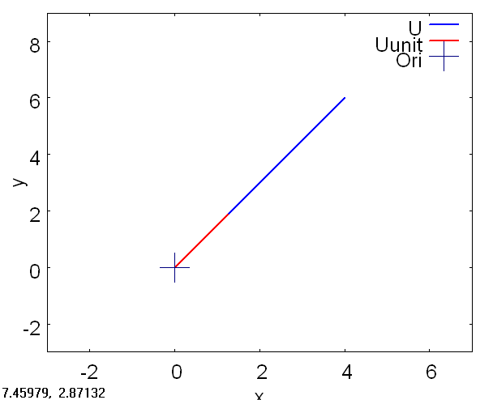

Funciones con valores vectoriales
(http://en.wikibooks.org/wiki/Calculus/Vectors)
Vector-Valued Functions are functions that instead of giving a resultant scalar value, give a resultant vector value. These aid in the create of direction and vector fields, and are therefore used in physics to aid with visualizations of electric, magnetic, and many other fields. They are of the following form:
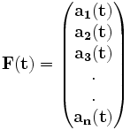

Ecuaciones paramétricas y funciones vectoriales
(De Cain y Herod: Multivariable Calculus, Ch. 3).
The real usefulness of vector descriptions is most evident when we consider curves
in space. Let f(t) = cos ti + sin tj + tk, for all t ≥ 0 . Now, what curve is followed by the
nose of f(t)? Notice first that if we look down on this curve from someplace up the
positive third axis (In other words, k is pointing directly at us.), we see the circle described
by cos ti + sin tj. As t increases, we run around this circle and the third component of our
position increases linearly. Convince yourself now that this curve looks like this:

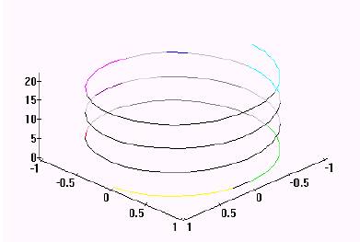

This curve is called a helix, or more precisely, a right circular helix. The picture was
drawn by Maple.
(Véase continuación, en la sección sobre Ecuaciones paramétricas, en el Acordeón para graficación con Maxima, “Espacio euclidiano, dimensiones, geometría analítica”.)

Límites y continuidad de las funciones vectoriales
Recall from grammar school what we mean when we say the limit at t0 of a realvalued,
or scalar, function f is L. The definition for vector functions is essentially the
same. Specifically, suppose f is a vector valued function, t₀ is a real number, and L is a
vector such that for every real number ε > 0, there is a δ > 0 such that | f (t) − L |<ε
whenever 0 | t - t₀| < δ and t is in the domain of f. This is traditionally written
lim f(t) = L
t→t₀
The vector L is called a limit of f at a.
Suppose α(t) is a scalar function for which lim α(t) = a, and f is a vector function
t→t₀

for which lim f(t) = L.
[...]
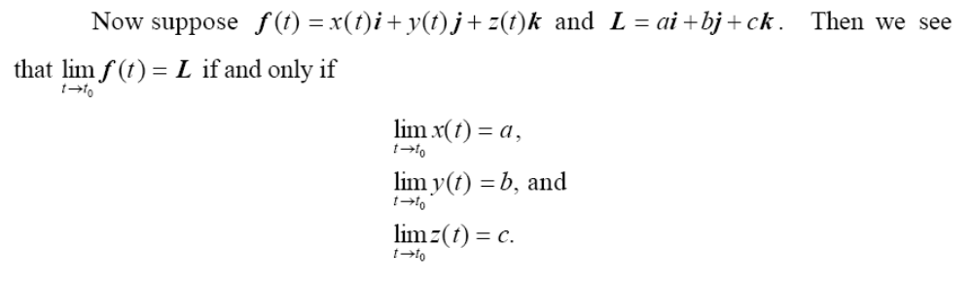
[...]
It is now easy to show that all the usual nice properties of limits are valid for vector
functions...

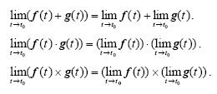
[...]
If f is continuous at each point of its domain, then we say simply that f is continuous,

Derivación de vectores
Cain y Herod, Ch. 4:

Specifically, we say that f is differentiable at t0 if there is a vector v such that
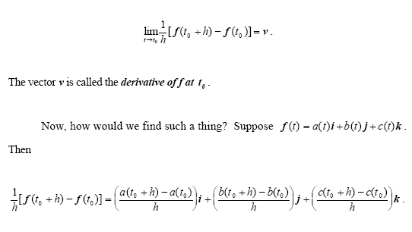

Integrales de superficie en campos vectoriales
De Wikipedia (http://en.wikipedia.org/wiki/Surface_integral):
Consider a vector field v on S, that is, for each x in S, v(x) is a vector. Imagine that we have a fluid flowing through S, such that v(x) determines the velocity of the fluid at x. The flux is defined as the quantity of fluid flowing through S in unit amount of time.
This illustration implies that if the vector field is tangent to S at each point, then the flux is zero, because the fluid just flows in parallel to S, and neither in nor out. This also implies that if v does not just flow along S, that is, if v has both a tangential and a normal component, then only the normal component contributes to the flux. Based on this reasoning, to find the flux, we need to take the dot product of v with the unit surface normal to S at each point, which will give us a scalar field, and integrate the obtained field as above. We find the formula
The cross product on the right-hand side of this expression is a surface normal determined by the parametrization.

